CSC 3150 – Systems Design
System Proposal
Template and Instructions

This template document contains a general outline with comprehensive details on the CSC 3150 System Proposal.
Part 1 will include the red bold-underlined sections.
The green reverse-formatted sections are for Part 2.
You might find it helpful to fill in the sections by replacing the prompts of this outline/template as you go. It is OK to submit Part 1 with the green prompts in place. Then, replace those with your additional information for Part 2. Part 2 should have none of this template's prompts in it.
YOUR AUDIENCE for this document is varied.
Your primary purpose is to communicate your understanding of the proposed system to your client (and other stakeholders). However, this document also introduces the project to developers working on or joining the project. Finally, creating this System Proposal helps your developer team solidify their understanding of the system to be built and document this understanding.
The System Proposal needs to be written in a way that non-technical types can understand so they can read it and determine if your analysis 1) makes sense and 2) matches what they believe they want and need. Assume all readers are busy and want to quickly and efficiently find the information they seek.
Example readers include:
- Wanderer's Tools, especially those involved in financing ideas and those interested enough in computing technology to want to have input into the process
- End-users (if she is wise, the Product Owner has contacted a few representative potential users to see if this system might appeal to them)
- Your organization's dev team

Note: document sections are numbered (except for the Executive Summary). Subsection numbering (e.g., 1.0, 1.1, 1.2, 1.3) is optional. Be consistent throughout the document and match the (auto-generated) Table of Contents numbering.

Advice: Give your proposed system a "Code Name". Constantly referring to your product as "The proposed travel journal for Wanderer's Tools" for the entire document is tiring for you and your reader. An acronym is nice but not required. You can also give your product or developer group a code name. You aren't "stuck" with that name, and it can be changed in the future.

Squared Meals
(aka. Meals Squared)
A Nutrition Balancing app

CSC 3150-40473 Systems Design
Adam Loepker
May 11, 2025

Table of Contents
[Automatically generated, as shown in class.]

Executive Summary
While the Executive Summary is the first thing your reader sees, wait and write it AFTER you have written the rest of the doc. DO NOT FORGET to add this to Part 2! It's a critical part of the document.

Analyze the Executive Summary sections of previous years' project proposal examples: what would be equivalent information for this project? You can put this on a separate page. Readers probably appreciate that, but it can also go above the Introduction and Overview if short. While the content may be like the Introduction and Overview, this is the official BRIEF introduction of yourself, your client, and the project.

1.0 Introduction and Overview

Problem Statement
Many people don't get all the nutrients they need, and it's hard for them to know what nutrients are in their food, making nutritional knowledge essential for good dietary choices. The last essential vitamin was discovered in 1948, and while food labels have been required since 1994, they provide only a limited view of a food's full nutrient profile. The USDA offers detailed food nutrition information online, but this data is cumbersome to track manually. This app aims to use technology to simplify food tracking.
A lack of awareness about specific nutritional deficiencies, which can lead to poor food choices and health problems. Packaged foods often lack essential nutrients and contribute to unbalanced diets, and food labels can be difficult to understand. Traditional diet tracking is often time-consuming and unsustainable, and generic dietary advice may not be suitable for individuals with specific health issues, allergies, or preferences. The modern food environment, with its abundance of processed foods and confusing diet tips, further complicates healthy eating and can lead to poor eating habits and long-term health problems.

Project Vision and Scope

My vision is an app system that empowers individuals to improve their nutrition at their desired commitment level. To achieve this, the initial phase will focus on developing a mobile application for both iOS and Android platforms. This app will enable users to track their food intake and monitor its nutritional value, supported by a comprehensive database of food nutrients. The scope of this phase includes creating this cross-platform mobile application and the underlying food nutrient database. Future phases may involve creating fully personalized diet plans, expanding the food database to include more specialized recipe foods, packaged foods, and restaurant menus, and even adding social networking features.

Requirements Summary
- Positive User Experience: Be easy and intuitive to use.
- Food Tracking: Help users easily measure and record their food intake.
- Data Accuracy: Provide accurate and up-to-date food information.
- Nutritional Guidance: Give users diet nutrient information and food suggestions.
- Progress Monitoring: Let users track their nutrient intake and progress over time.
- Data Security: Keep user data safe and secure.
- Scalability: Be able to handle data for a large number of users.
- Platform Compatibility: Work on both iPhones and Android phones.

Stakeholders and Their Interests
- End-users: Individuals seeking to improve their dietary habits and overall health. An app that is easy to use, provides personalized and accurate recommendations, is affordable, and protects their privacy is what they need.
- Developers: The team responsible for designing, developing, and maintaining the application. Clear project requirements, adequate resources, technical feasibility, and a well-defined project timeline are important to them.
- Nutritionists/Dieticians: Health professionals who may use the app with their clients. They look for scientific validity in the data, customization options to suit individual client needs, and integration with their professional tools.
- Investors/Funding Sources: Those providing the money, like venture capitalists or angel investors. A good return on their investment, the app's potential in the market, and the team's ability to deliver on time and within budget are their primary concerns.
- Regulatory and Legal Bodies: Organizations that oversee data privacy and healthcare-related applications as well as and lawyers to ensure legal compliance.

Expected Costs and Benefits
Costs:
- App development costs
- Costs to gather and update food data
- Server and storage costs
- Marketing and advertising costs
- Ongoing support costs
- Legal costs
- Cost of expert consultation (nutritionists, dieticians)
Benefits:
- Improved dietary habits
- Better health
- Increased awareness of nutritional needs
- Personalized dietary recommendations
- Convenient food tracking
- Revenue from health initiative programs or donations
- Revenue from premium subscriptions or app purchase maybe (AI-powered personalized features or free food scale or something maybe)

Constraints
- Budget: Limited financial resources initially.
- Technical limitations: Potential issues with technology (specifically measuring food).
- Data accuracy: Ensuring food database accuracy.
- Regulatory compliance: Adherence to data privacy and any healthcare regulations.
- User adoption: Getting people to use and stick with the app over other alternatives.

Recommendation
What do you want your reader to do upon receipt of this document? Wanderer's Tools is your primary decision-maker; what actions should they take after reading your proposal? What "next steps" should now be taken? DO NOT FORGET to add this to Part 2!

Document Overview (add detail)
Describe the organization and content of the rest of the System Proposal.
Be sure this needs to be updated for the Part 2 submission to include the entire document.

- 2.0 System Initiation - Project Initiation Request
- 3.0 Feasibility Assessment
- 4.0 Requirements Definition
- 5.0 Requirements Model
- 6.0 System Evolution
- 7.0 Conclusions and Recommendations
- Appendices
- Glossary

2.0 System Initiation

PIR-00000 [PIR Number to be assigned by the Project Office] Project Initiation Request (PIR) – Level1 v6.0
Project Name: Squared Meals Student Name: Adam Loepker

This Project Initiation Request (PIR) is to be completed for all requests expected to require over 40 hours of effort or over 4 weeks of total duration. For larger requests requiring over 40 person-days or estimated project costs greater than $5,000, this template is used to assess the product's feasibility and get approval to scope and plan the proposed project.
If approved, the Level 2 template (System Proposal: Part 1 and Part 2) must be completed.
NOTE: Sections 0-4 are required. Section 5 is optional, but any ideas on estimating costs should be included. Replace the italic prompts with your answers/information. [Expand each section in this template as needed.]
0. General Project Information
Project Name: | (Meals)² (a.k.a.: Squared Meals)
Two Sentence Request Description: | People could use an app that can track what you are eating currently and suggests what you could add to bridge the gap to better health. Most people are deficient in at least one nutrient which could be affecting their health.
Requested Launch Date(s): | June 2026
Department(s) Affected By Project: | Development, marketing
Project's Customers: | Nutrition focused individuals
Date Request Submitted: | 4/20/2025
- Project Sponsor and Manager
Project Sponsor |  |  | Business Project Manager & Requestor
Name: | Andy Cameron |  | Name: | Adam Loepker
Title: | Professor |  | Title: | Student
Department: | Computer Science - SPU |  | Department: | Computer Science - SPU
eMail: | acameron@spu.edu |  | eMail: | LoepkerA@spu.edu

- Business Problem or Opportunity: The motivation for this request
Describe the problem or opportunity that you would like to solve. Include a simple, high-level description of this request's business problems or opportunities. Focus on the problem or opportunity, not the solution. Be sure to include any date or deadline-related dependencies or needs related to the project.
Most people have at least one nutrient deficiency, and humans lack the ability to detect most nutrients in their food supply. This means they require nutritional knowledge about the potential food supply to make the best possible decisions.
The last of the 28 essential vitamins and minerals weas not even discovered until just 77 years ago (1948), nutrition labels weren't required to be on food until just 30 years ago in 1994 and only offer a slim glimpse at the full nutrient profile of any food.
The USDA has listed nutrition details of different foods on their website, but it is cumbersome to track each food you eat in a personally made spreadsheet. This presents an opportunity to use technology to quickly automate several parts in the nutrition tracking process to make it practical for most people to be able to do.
This app doesn't necessarily intend to perfect one's diet, more to offer useful real-world suggestions for getting closer to meeting dietary needs.

- Justification, Impact, and Importance
What is the financial impact and justification for this request? How will the investment of time, resources, and capital be returned to our company? (Please note any contractual or regulatory requirements associated with the request. If you have an NPV, IRR, or ROI calculation, please provide the link(s) in this section.)
Assumptions
- People have nutrient deficiencies
- People can’t sense most specific nutrients in their food.
- Many people would make better choices given the knowledge

Competitive Landscape / Context
- USDA website with excel
- Chronometer app
- Guessing

Tangible Return, Opportunity, or Value One Time On-Going
- Possibly an app purchase feature of some kind/ (harder if the goal is more people to use the app) | $ ? | $ ?
- Maybe sell eating pattern data and or ad-space, would prefer to be ethical though. | $ ? | $ ?

Intangible Benefits Impact or Value
- Better Health | $ 0
- More Years with Loved Ones | $ 0

- Product Requirements
The Project team will gather detailed requirements once the project is approved. Use this section to articulate the critical solution components to help scope the project's size and complexity. Do not describe how the solution will be implemented; instead, only list the functionality or results you expect to receive when the product is complete/delivered.
  - Must Haves
    - Interface for adding or scanning food
    - Database of food for comparison

  - Could Haves (Nice to Haves)
    - AI tracking (Paid feature maybe?)
    - A way to estimate what is in different processed foods if not explicitly provided

  - Won't Haves (Don't Do's, aka Out of Scope)
    - Psychological help to stick to dietary plans.
    - A way to keep you from food you are not supposed to be eating.
- Project Costs (Operating and Capital: Onetime and Recurring) [Optional]
This section is typically fleshed out after the requestor has submitted a PIR and received approval for the initial scoping effort. It captures the effort estimates, capital expenditures, and other costs associated with performing this work and creating the product/solution. If the submitter has thoughts or estimates on what these costs are or suggestions on how they might be estimated, please include those here. Add brief descriptions as needed. Include at least 2 comments on your thinking around these items, even if you don't have specifics yet.
Labor Costs
Type | Team(s) Affected | Low (hrs) | High (hrs)
Analysis & Design |  | 0 | 0
Development |  | 0 | 0
Testing and Quality Assurance |  | 0 | 0
Systems Integration |  | 0 | 0
Deployment |  | 0 | 0
Support and Maintenance |  | 0 | 0
Sales and Marketing |  | 0 | 0
Total |  | 0 | 0
Comments: Include notes here on what the costs are or how they can be estimated. (optional)
Capital Costs (Equipment, Software, Licenses, …)
Description | Quantity | Cost ($)
Item 1 |  | $ 0
Item 2 |  | $ 0
Total |  | $ 0
Comments: Include notes here on what these are or how they can be estimated. (optional)
Maintenance Costs (Costs after the product is live)
Type | Hours / Month Low | Hours / Month High
System / User Support | 0 | 0
Business / Process Support | 0 | 0
Total Support & Maintenance | 0 | 0

3.0 Feasibility Assessment

Introduction
This part examines the technical, resource, schedule, organizational, legal, and contractual aspects of the project to determine its Feasibility. Each area is analyzed to identify potential challenges and risks. A rating scale is used in the Feasibility Analysis section to provide a clear assessment of each area:
High Feasibility: The project has a very high likelihood of success in this area.

Average Feasibility: The project is likely to succeed, but some challenges may need to be addressed.

Low Feasibility: Significant challenges exist, and the project's success in this area is doubtful.

Infeasible: The project is not feasible in this area.

Feasibility Analysis (redo)
- Technical Feasibility: The technology we need to build this app is readily available. This includes things like the tools to build mobile apps for both iPhones and Android phones, database systems to store the data, and cloud services. There are already similar apps out there, which shows that it's definitely doable. However, there might be some challenges in adding more complex features. Rating: Moderate Feasibility

- Resource Feasibility: Since this is currently just an idea and there's no company yet, getting the necessary resources is a major concern. It will be hard to find and hire developers, designers, and database experts. Also, we don't have funding yet, which makes it difficult to estimate how much things will cost or to guarantee that we'll have the money to pay for development, the necessary computer infrastructure, and ongoing maintenance. Rating: Low Feasibility

- Schedule Feasibility: The initial plan estimated a 6-month development phase, followed by testing and deployment. This assumed a full development team. However, a solo developer will need significantly more time to handle all aspects of the project, including design, iOS and Android coding, database setup, testing, and deployment. A more realistic estimate for a single developer is 12 to 18 months. Rating: Low Feasibility

- Legal Feasibility: The app has to comply with all the relevant laws and regulations, especially those related to data privacy and health information. Rating: Moderate Feasibility

- Contractual Feasibility: We'll need to establish contracts with vendors for things like cloud hosting, getting the food data, and integrating with other services. Given that this is just an idea, it might be too early to establish these contracts, and it might be difficult to do so until we have funding and a company structure in place. Rating: Low Feasibility

- Organizational Feasibility: In Progress

Additional Comments (add)
Put whatever is appropriate here.

Conclusion (redo)
The project holds promise, and with a full and well-coordinated team, its potential could be significantly enhanced. A dedicated team would bring higher quality, a faster development timeline, and more effective risk management. Securing funding to assemble this team, therefore, could be a critical next step to move this project forward.
For more limited resources, a focused approach is essential. Initially, the development could concentrate on a Minimum Viable Product (MVP) with core features: basic food tracking, a limited food database, and essential nutrient information. Open-source tools and frameworks can help minimize costs to get things off the ground.

4.0 Requirements Definition

Introduction
This section outlines the functional and non-functional requirements for the Diet Suggestion App. Requirements define what the system should do and how it should perform.
- Functional Requirements: These describe the specific actions and functions that the system must perform.
- Non-Functional Requirements: These describe the qualities that the system must have, such as usability, performance, security, and reliability.
The functional and non-functional requirements are detailed next:

Functional Requirements

User Registration and Authentication:
- The system must allow users to create an account with a unique username, email address, and password.
- The system must authenticate users securely when they log in.
Food Input and Tracking:
- The system must allow users to input their food intake, specifying the type and quantity of food consumed, and provide a user-friendly interface for searching, selecting, or scanning food items directly from a database using image recognition technology.
Food Database Management:
- The system must include a comprehensive database of food items with their nutritional information (calories, macronutrients, vitamins, and minerals).
- The system must allow for the database to be updated and expanded
Nutritional Analysis:
- The system must calculate the nutritional content of the user's food intake based on the food database.
- The system must display the nutritional breakdown to the user in a clear and understandable format.
Dietary Recommendations:
- The system must provide users with dietary recommendations based on their nutritional intake needs and goals.
- The system should allow for some level of personalization of recommendations, such as considering dietary restrictions or preferences.
Progress Monitoring:
- The system must allow users to track their nutritional intake and progress over time.
- The system must provide visual representations of the user's progress, such as charts and graphs or emotive characters.

Include a written overview of the system's functional requirements. The requirements should be organized logically (so that the system makes sense to the reader and they can determine if all services are included). The preferred format would be a bulleted or numbered list of requirements. Each requirement should be given a "name" (highlight this somehow) and a 1 or 2-sentence description. This number and name are critical when you refer to and cross-reference these requirements with the Use Cases of Section 5!
You are urged to classify your requirements using the MoSCoW approach – Must, Should, Could, and Won't. "Must" and "Should" requirements become the central focus of your eventual use case Requirements Model (section 5.0). "Could" requirements should also appear in section "6.0 Evolution". The "Won't" requirements help define the system scope further, explicitly listing those things that are out of scope for the initial MVP phase.
The level of abstraction shown in the attached sample (below) is an excellent guide and is most helpful to developers. Make sure no user needs have been left out (as much as possible at this point). You don't need to be step-by-step in your description of each requirement unless it is required to understand the feature or concept. For example, you don't need to say, "The user enters their name, then their address, then clicks Save". There is time for that detail later – in the 2nd document, the System Specification!
IMPORTANT—read and re-read your functional requirements to ensure they are action-oriented and focused on your product's essential services and value.
If you think some requirements would be best put off until later versions of the product, note that here. For Part 2 Submission – these "Version 2" future requirements must also be included in the System Evolution section (Section 6).
COMPLETE DOCUMENT REQUIRED REVISION: All functional requirements must be represented in the Requirements Model (Use Cases) unless the analyst forgets them (which is bad). To help the reader confirm that all functional requirements have been modeled, include specific cross-references to the Section 5 Use Case associated with each requirement.
Any requirements not included in the MVP use cases (those for later versions) MUST be described in the System Evolution Section, so send your reader to that section for more information.

Data Requirements
Capture the primary known data needs for the system in this section. Take notes for this as you complete the first submission (Part 1), but you don't need to submit it until the second submission (Part 2), as Use Case modeling reveals additional data needs. Try to group these in a way that makes sense. Presenting data requirements in an organized fashion helps database designers and software devs down the road!

Non-functional Requirements
- Usability: The app should be easy to use and navigate, with a clean and intuitive interface.
- Performance: The app should be responsive and efficient, with minimal loading times.
- Security: The app should protect user data and ensure secure authentication and data storage.
- Reliability: The app should be stable and reliable, with minimal downtime and errors.
- Scalability: The app should be able to handle a large number of users and data.
- Compatibility: The app should be compatible with both iOS and Android devices.

This section is a brief written overview of the system's non-functional requirements. These should be organized logically and categorized, as shown in the attached example. A bulleted or numbered list style is also good here. "Naming" the non-functional requirements is unnecessary, and you can use a bulleted list instead of complete sentences (as long as they make sense). If a non-functional requirement pertains to a specific functional requirement, refer the reader to that requirement. If there are alternatives, present them here.

5.0 Requirements Model
Introduction
Start with a brief text overview of what the drawing and supporting documentation show. Remember, some of your readers may be customers or end-user types unfamiliar with Use Case Diagrams and Descriptions, so you need some overview descriptions here. Again, avoid sounding like a textbook (or class notes) via direct copying.
Use-Case Diagram
Create these using a good drawing tool like LucidChart, draw.io, Google Drawing, Apple Notes, or others.
Use-Case Descriptions
You must complete a separate Use Case Description template for each Use Case in your Use Case Diagram. Each Use Case description MUST begin on a separate page.

6.0 System Evolution
This section answers the question, "What about the future?" It is a brief discussion of any desired system features not part of the MVP initial version (see the corresponding comment in the description for Section 3.0). Also, include any planned or recommended upgrades to hardware/software for continued system use or expansion.

7.0 Conclusions and Recommendations.
These may be organized as two separate sections or two distinct parts of section 7. In either case, this is one place where a section introduction is neither needed nor recommended.

Appendices
Include (at least) a copy of any completed questionnaires or surveys, plus any other applicable reference materials. Be sure to update the Appendices for Part 2.

Glossary
- App: Short for "application," a software program designed to run on a mobile device.
- Database: A way data stored.
- FDA: Food and Drug Administration, a federal agency responsible for protecting public health.
- iOS: The operating system used for Apple mobile devices.
- Android: A mobile operating system based on a modified version of the Linux kernel and other open-source software, designed primarily for touchscreen mobile devices such as smartphones and tablets.
- Macronutrients: The main nutrients that make up our diet: protein, carbohydrates, and fats.
- Micronutrients: Essential nutrients, such as vitamins and minerals, that are required by the body in small amounts to function properly.
- Nutritional Information: Data on the nutritional content of foods, including calories, macronutrients, and micronutrients.
- UI: User Interface, or the way the user and a computer system interact.
- USDA: United States Department of Agriculture, the federal department that provides leadership on food, agriculture, natural resources, and related issues.

Always include a glossary and use it to define any technical terms, business terms, or abbreviations used in the document that a potential reader may not know. Since you cannot make any assumptions about the experience or expertise of the reader, it is best to be on the safe side and define more rather than fewer terms here in the glossary. However, even if you have defined terms inline within the text, it is also best to include them in this section. The Glossary is a vital section, make sure it covers your entire set of artifacts before submitting Part 2.

References
Nothing so far
With proper APA Version 7 citation, include all sources you have consulted in defining the application domain, any CASE tools used, and any other resources you have used.
Cover #2 free image - https://pixabay.com/illustrations/numbers-two-2-drop-shadow-1487225/
Cover parentheses free image - https://www.cleanpng.com/png-bracket-punctuation-ditto-mark-question-mark-langu-4942353/9.html
Cover free meal image - https://www.freepik.com/free-psd/roasted-chicken-dinner-platter-delicious-feast_407745033.htm#fromView=keyword&page=1&position=0&uuid=abcbbf68-b199-4d4c-b2af-0f2ed5b7ed00&query=Meal

Everyone needs a References page since you have at least your CSC 3150 notes, lectures, drawing tool, and anything else you used to research and create this document. Be sure to update the References for Part 2.

For Part 2 submission:
- All the above sections are to be included as a single document.
- All corrections and suggestions from the grader are to be addressed, as are all customer questions received in the document reviews.
- Any changes to the first submission's functional requirements or feasibility study resulting from what you learned while creating the second half of the document should be made in each section. Use "Track Changes" in MS Word so all the changes from Part 1 to Part 2 are denoted. Your submission may be returned to you if you do not do this. Remember that the reader can always turn off "Track Changes" to see a clean Part 2 document artifact. It would be best to do this with a copy of your document before submitting it to Canvas to ensure that the clean version formats how you want it to look. But be sure to submit to Canvas with "Track Changes" turned on so your Part 1 -> Part 2 changes are apparent.

That's it!

Good luck! I look forward to reading both parts of your System Proposal!
-Professor Andy
Feasibility Analysis Example

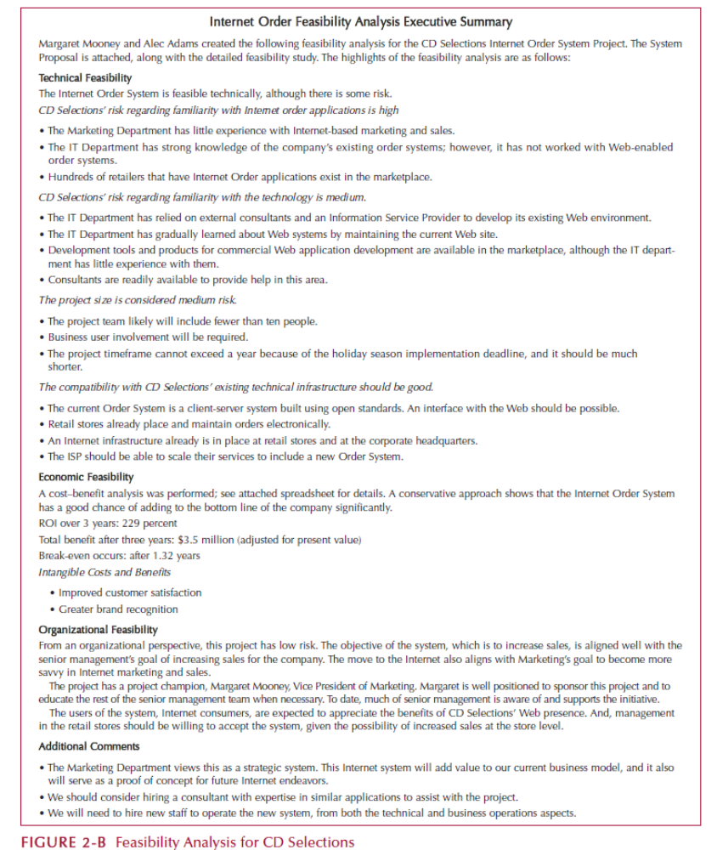

Requirements Definition Example

